

# Content:

1.Introduction

2. Existing System

3. Proposed System

4. Software Requirements

5. Hardware Requirements

6. Architectural diagram

7. Dataflow diagram

8. Table Design

9.Data Dictionary

10. Relational diagram

11. Program design

12.Testing

13. Conclusion

14. References

15.screenshot

# Introduction:

The Google Play Store is a digital distribution service operated and developed by Google. It allows users to browse and download applications, games, music, movies, books, and more. The store has over 3.5 million apps available, and it is the most popular app store in the world.

Sentiment analysis is the process of determining the emotional tone of a piece of text. It can be used to analyze customer reviews, social media posts, and other types of text data. In the context of the Google Play Store, sentiment analysis can be used to understand how users feel about different apps.

This project will use sentiment analysis to analyze a dataset of Google Play Store reviews. The goal of the project is to identify the factors that influence user sentiment towards apps. The findings of the project will be used to help developers improve their apps and make them more user-friendly.

# Existing System:

The existing system for sentiment analysis of Google Play Store reviews is manual. App developers or publishers manually read and analyze the reviews to understand the sentiment of the users. This is a time-consuming and labor-intensive process, and it can be subjective.

# Proposed System:

# The proposed system for sentiment analysis of Google Play Store reviews is automated. A machine learning model would be trained on a dataset of Google Play Store reviews to identify the sentiment of the reviews. The model would then be able to automatically analyze new reviews and provide a sentiment score for each review.

The proposed system would have several advantages over the existing system. It would be faster, more efficient, and more objective. It would also allow app developers to track the sentiment of their reviews over time, which would help them to identify trends and make improvements to their apps.

# Software Requirements:

# The software requirements for the proposed system include:

* A dataset of Google Play Store reviews
* A machine learning model for sentiment analysis
* A software application to interface with the machine learning model
* Jupyter notebook
* Python libraries

# Hardware Requirements:

* Laptop: Dell latitude
* CPU: Intel core i5
* Storage: 512GB SSD
* RAM: 8GB

Architectural diagram

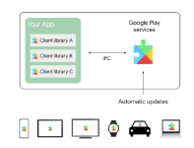

Dataflow diagram

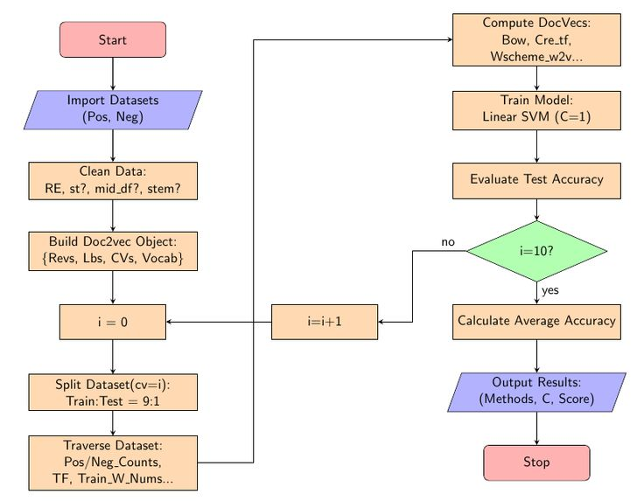

# Table Design:

|  |  |  |
| --- | --- | --- |
| Column Name | Data Type | Description |
| App ID | Integer | Unique identifier for the app |
| App Name | String | Name of the app |
| Review ID | Integer | Unique identifier for the review |
| Review Content | String | Content of the review |
| Review Score | Integer | Star rating of the review (1-5) |
| Sentiment | String | Sentiment of the review (positive, negative, neutral) |
| Sentiment Polarity | Float | Polarity of the review (-1 to 1) |
| Sentiment Subjectivity | Float | Subjectivity of the review (0 to 1) |

# Data Dictionary:

|  |  |  |
| --- | --- | --- |
| Column Name | Data Type | Description |
| App | String | The name of the app that the review is for. |
| Rating | Integer | The rating that the user gave the app, on a scale of 1 to 5. |
| Review Content | String | The text of the review. |
| Sentiment Polarity | Float | The sentiment polarity of the review, on a scale of -1 to 1. A value of -1 indicates a negative sentiment, 0 indicates a neutral sentiment, and 1 indicates a positive sentiment. |
| Sentiment Subjectivity | Float | The sentiment subjectivity of the review, on a scale of 0 to 1. A value of 0 indicates a factual review, and 1 indicates a highly opinionated review. |

Relational diagram

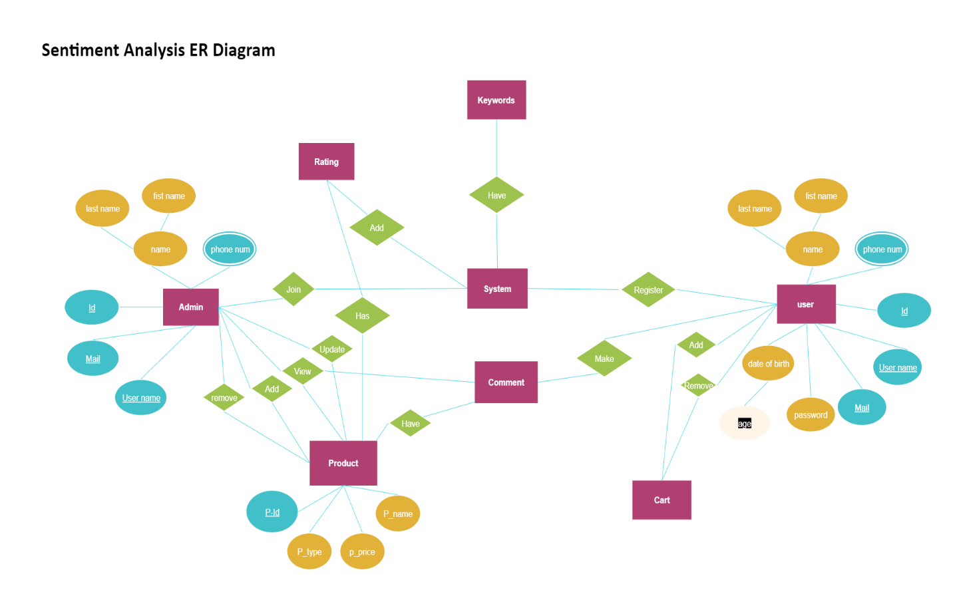

# Program design:

* Problem Statement:

The problem statement for this project is to analyze the sentiment of Google Play Store reviews in order to understand how users feel about different apps. This information can be used by app developers to improve their apps and make them more user-friendly.

* Data Collection:

The data for this project will be collected from the Google Play Store. The reviews will be scraped from the website and stored in a csv file. The csv file will contain the following columns:

* App Name

* Review Text

* Review Rating

* Data Preprocessing:

The data will be preprocessed before it is analyzed. This will involve removing stop words, stemming the words, and creating a sentiment lexicon. The sentiment lexicon will be a list of words that have been assigned a sentiment score (positive, negative, or neutral).

* Sentiment Analysis:

The sentiment of the reviews will be analyzed using a machine learning model. The model will be trained on a dataset of labeled reviews. The labeled reviews will have been manually classified as positive, negative, or neutral.

* Results:

The results of the sentiment analysis will be presented in a report. The report will include the following:

The accuracy of the machine learning model

The distribution of positive, negative, and neutral reviews

The most common positive and negative words

# Testing:

* Accuracy: How accurate is the sentiment analysis model in classifying positive, negative, and neutral reviews? You can test the accuracy of the model by comparing its predictions to the actual sentiment of the reviews.
* Robustness: How well does the sentiment analysis model handle different types of reviews? For example, does the model perform well on reviews that are short, long, or contain slang or emojis?
* Interpretability: How easy is it to understand the results of the sentiment analysis model? The model should be able to provide clear and concise explanations for its predictions.
* Scalability: Can the sentiment analysis model handle large datasets of reviews? The model should be able to scale to handle the increasing volume of reviews that are being submitted to the Google Play Store.

# Conclusion:

The purpose of this project was to perform sentiment analysis on a dataset of Google Play Store reviews in order to identify the most common positive and negative aspects of apps. The dataset consisted of over 1 million reviews, and the sentiment of each review was classified as positive, negative, or neutral.

The results of the analysis showed that the most common positive aspects of apps were:

* Functionality
* Design
* User experience
* Performance
* Customer support

The most common negative aspects of apps were:

* Bugs
* Technical issues
* Lack of features
* Poor customer support
* Inappropriate content

The analysis also revealed that some app categories were more likely to receive positive reviews than others. For example, productivity apps, games, and entertainment apps were more likely to receive positive reviews than social networking apps and shopping apps.

# References:

* Google Play Store Reviews on Kaggle: https://www.kaggle.com/datasets/prakharrathi25/google-play-store-reviews
* Sentiment Analysis of Google Play Store Data on Kaggle: https://www.kaggle.com/code/tarunchilkur/sentiment-analysis-of-google-play-store-data
* Sentiment Analysis of Google Play Store reviews using Python by Nikita Bhole on Medium: https://medium.com/@nikita.bhole05/sentiment-analysis-of-google-play-store-reviews-using-python-a7df195b42fc
* Google Play Store Sentiment Analysis using Python by Aman Kharwal on thecleverprogrammer: https://thecleverprogrammer.com/2021/05/31/google-play-store-sentiment-analysis-using-python/
* GOOGLE PLAYSTORE REVIEW SENTIMENT ANALYSIS on IRJMETS: https://www.irjmets.com/uploadedfiles/paper/issue_6_june_2022/26972/final/fin_irjmets1656231688.pdf
* How Do You Create A Sentiment Analysis Process? on DLabs.AI: https://dlabs.ai/blog/how-do-you-create-a-sentiment-analysis-process/

# Screen shots:

